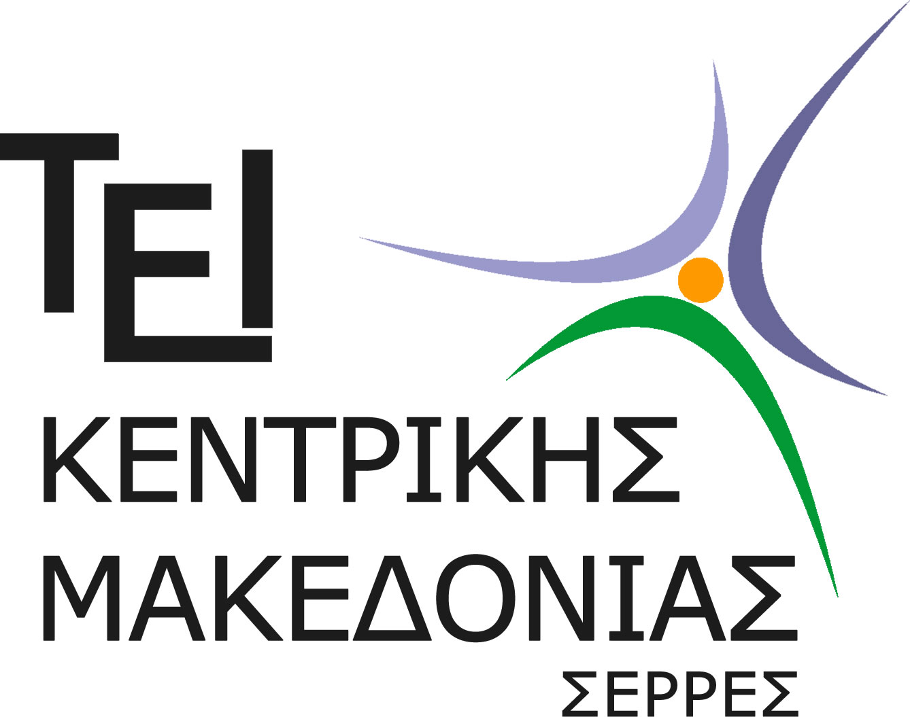
Technological Educational Institute of Central Macedonia
DEPARTMENT OF CIVIL ENGINEERING TECHNOLOGICAL EDUCATION AND SURVEYING ENGINEERING AND GEOINFORMATICS TECHNOLOGICAL EDUCATION

SPECIALIZATION COURSE IN SURVEYING ENGINEERING AND GEOINFORMATICS

Prot. Nr …………

Serres ..../..../........

THE DIPLOMA SUPPLEMENT
This diploma supplement model was developed by the European Commission, council of Europe and Unesco/ Cepes. The purpose of the supplement is to provide sufficient independent data to improve the international “Transparency” and fair academic and professional recognition of qualifications (diplomas, degrees, certificates e.t.c.). It is designed to provide a description of the nature, level, context, content and status of the studies that were pursued and successfully completed by the individual named on the original qualification to which this supplement is appended. It should be free from any value judgments, equivalence statements or suggestions about recognition. Information in all eight sections should be provided. Where information is not provided, an explanation should give the reason why.

1. INFORMATION IDENTIFYING THE HOLDER OF THE QUALIFICATION
- Family name(s): ……………………………………………………………………………………………….
- Given name(s): ………………………………………………………………………………………………..
- Date of birth (day/month/year) – Place - Country of Birth: …………………………………………………………………….
- Student identification number or code: …………………………………………………………………….

2. INFORMATION IDENTIFYING THE QUALIFICATION
2.1 Name of qualification and title conferred in original language:
Degree of Civil Engineering, Technological Education
2.2 Main field(s) of study for the qualification:

Civil Engineering Works
2.3 Name and status of awarding institution:

Technological Educational Institute of Central Macedonia
2.4 Name and status of institution administering studies:

Technological Educational Institute of Central Macedonia
2.5 Language(s) of instruction/examination:

Greek

3. INFORMATION ON THE LEVEL OF THE QUALIFICATION
3.1 Level of qualification:
Basic higher education qualification (Level Bachelor)
Level 5Α (ISCED classification system of UNESCO)
3.2 Official length of program:
Years: 4
Weeks per year: 26
Credits ECTS: 240
Total workload: 401 hours
Practice: Six-month internship during the studies
3.3 Access requirement(s):
With High School Certificate and Certificate examinations or Technical Vocational School Certificate (percentage of imported students 10%) and examinations

4. INFORMATION ON THE CONTENTS AND RESULTS GAINED

4.1 Mode of study:
Full-time

4.2 Program requirements:

The syllabus provides the graduates with all the necessary knowledge and skills in the field of Surveying Engineeriing and Geomatics and a background knowledge in selected subjects (mathematics, applied geology, computer aided desing) in order to allow continuous monitoring of technological development as well as the uptake and active participation in the development of new technologies

The syllabus is consisted by the following units :

- Topographic and Geodetic networks
- Geographical Information Systems
- Cadastral Surveying
- Geomatics and Transportation
- Digital Cartography and Mapping
- Satellite Geodesy
- Remote Sensing
- Urban and Regional Planning
- Environmental Planning and Spatial Analysis
- Ecology and Sustainability
- Human Geography and Spatial Economics
- Digital Documentation of Cultural Resources
- Urban Planning and Environmental Legislation
- Research methodology (the ability to collect, evaluate, analyze and synthesize data)

The performance of the students is assessed in a number of ways including both mid-term and final exams as well as coursework.

According to the Regulation of Studies, a graduate student completes his studies when he:
(a) has successfully completed all the courses and has received 210 credits ECTS
(b) has his thesis work approved (20 credits ECTS)
(c) has completed the 6-month practical training on the profession (10 credits ECTS)
Total of ECTS credits: 240
More information: URL: www.geocivil,teicm.gr

4.3 Program details: (e.g. modulus or units studied) and the individual grades/marks/credits obtained:

Courses of General Infrastructure (C.G.I.) & Management, Economics, Law and Humanities (M.E.L.H.)

Α/Α | Code | Course Title | Semester | Credits ECTS | Grade
1. | 101 | Mathematics | Α | 7
2. | 102 | Applied Informatics I | Α | 6
3. | 103 | Statistics and Elements of Probability Theory | Α | 4
4. | 104 | Computer-Aided Design | Α | 4
5. | 105 | Surveying I | Α | 5
6. | 106 | Writing Technical Texts | Α | 4
7. | 203 | General and Applied Geology | B | 5
8. | 205 | Course in English Language | B | 4
9. | 304 | Human Geography and Spatial Economics | Γ | 4
10. | 404 | Quantitative methods in Geographical Analysis | Δ | 4
11. | 406 | Urban Space Transformations | Δ | 5
12. | 505 | Environmental Legislation * | E | 4
13 | 506 | Decision Support Systems and GIS* | E | 4
14 | 703 | Ecology and Sustainable Development | Ζ | 6
 |  | Total |  | 62
*Elective compulsory courses 1

Courses of Special Infrastructure (C.S.I.)

Α/Α | Code | Course Title | Semester | Credits ECTS | Grade
1. | 206 | Introduction to Cartography | B | 5
2. | 301 | Photogrammetry I | Γ | 6
3. | 302 | Regional Planning and Development | Γ | 5
4. | 306 | Algorithms in Geomatics | Γ | 5
5. | 401 | GIS I | Δ | 6
6. | 403 | Geomatics and Transportation | Δ | 5
7. | 405 | Cadastral Surveying | Δ | 5
8. | 503 | Remote Sensing | E | 7
9. | 601 | Applications in Regional and Urban Planning (GIS III) | ΣΤ | 7
10. | 604 | Acts of Settlement and Actuarial | ΣΤ | 6
11. | 605 | Urban Planning** | ΣΤ | 5
12. | 606 | Environmental Planning and Spatial Analysis** | ΣΤ | 5
13. | 702 | Automation Systems Applications and Local Authorities | Ζ | 5
14. | 705 | Geomatics Software Design and Development *** | Ζ | 6
15. | 706 | Cultural Documentation Systems*** | Ζ | 6
 |  | Total |  | 73
** Elective compulsory courses 2
*** Elective compulsory courses 3

Courses of Specialization (C.S.)

Α/Α |  | Course Title | Semester | Credits ECTS | Grade
1. | 201 | Surveying II | B | 5
2. | 202 | Applied Informatics II | B | 6
3. | 204 | Programming in Design Software | B | 5
4. | 303 | Databases | Γ | 5
5. | 305 | Road Engineering | Γ | 5
6. | 402 | Photogrammetry II | Δ | 5
7. | 501 | Satellite Geodesy (GPS) | E | 8
8. | 502 | GIS Applications (GIS II) | E | 6
9. | 504 | Thematic and Digital Cartography | E | 5
10. | 602 | Topographic and Geodetic Networks | ΣΤ | 5
11. | 603 | Remote Sensing Applications and Mapping | ΣΤ | 7
12. | 701 | Cartographic Visualizations | Ζ | 7
13. | 704 | Applied Urban Planning | Ζ | 6
 |  | Total |  | 75

(*) Thesis Title :…………………………………………………………..
(**) Internship (6 months) has been practiced in ……………………………...

4.4 Rating scheme and, if available, grade distribution guidance:
According to the regulations the rating scale is organised as follows:
8,5-10 : "Excellent"
7,0-8,4 : "Very Good "
5,0-6,9 : "Good"
4,0-4,9 : "Insufficient"
0,0-3,9 : "Bad"
For the successful completion of a course the rating should be greater than 5.0.
More information on www.teiser.gr

  - Overall classification of the qualification (Greek):
Concerns each student individually (for example: 8.2 Very good)

5. INFORMATION ON THE FUNCTION OF THE QUALIFICATION

5.1 Access to further studies:
The degree of the Department provides access to postgraduate studies for a Master's Degree or Ph.D. degree.

5.2 Professional status:
Upon completion of their studies, graduates of the Direction of Surveying and Geomatics, Tech. Ed., acquire the appropriate scientific and technological knowledge and skills, in order to be employed in any field of their scientific field, either as self-employed or as project leaders in relevant practices, Organizations and Services, and to apply contemporary scientific, technological, construction, research, managerial, educational, institutional and ethical practices and methods in exercising their profession in the following fields:

- Surveying
- Applied Geology
- Topographic and Geodetic networks
- Geographical Information Systems
- Cadastral Surveying
- Geomatics and Transportation
- Digital Cartography and Mapping
- Satellite Geodesy
- Remote Sensing
- Urban and Regional Planning
- Environmental Planning and Spatial Analysis
- Ecology and Sustainability
- Human Geography and Spatial Economics
- Digital documentation of cultural resources
- Urban Planning and Environmental legislation
- Research methodology (the ability to collect, evaluate, analyze and synthesize data)

In concluding, the graduates of the Direction may exercise efficiently any professional activities as a Surveying and Geomatic Engineer

More information: URL: www.teiser.gr

6. ADDITIONAL INFORMATION
6.1 Additional information:

......................................................................................................................................................................
…………………………………………………………………………………………………………………
…………………………………………………………………………………………………………………

6.2 Further information sources:
- Ministry of Education Website: www.ypeth.gr
- Website of the Department of Civil Engineering and Surveying Engineering and Geoinformatics : http://civilgeo.teicm.gr/

- Technological Educational Institute (TEI) of Central Macedonia, Serres

DEPARTMENT OF CIVIL ENGINEERING, SURVEYING ENGINEERING & GEOMATICS - 62124 SERRES

7. CERTIFICATION OF THE SUPPLEMENT

Date:

…………………………………………………………………………………………………….

Secretary of the Department Head of Department

Official Stamp

Signature Signature

8. INFORMATION ON THE NATIONAL HIGHER EDUCATION SYSTEM

http://www.eurydice.org
http://www.eurydice.org/Eurybase/frameset.eurybase.html

Education in Greece is compulsory for all children aged between 6-15 years old. It contains the Primary (Elementary) and Lower Secondary School (High School - Gymnasium).

The post-compulsory secondary education, according to the educational reform of 1997, comprises of two school types: Unified Upper Secondary Schools (Lyceums) and the Technical Vocational Schools (TEE). Attendance lasts three years at Lyceums and two years (cycle 1) or three years (cycle 2 - additional year) in the Technical Vocational Educational. Transfer of pupils between the aforementioned school types is also possible.

The post-compulsory secondary education also includes the Vocational Training Institutes (IEK), which offer formal training but they have no official classification.

Higher education is public and available in Universities and Technological Educational Institutes (TEI). Student’s admission in these institutions depends on their performance in national examinations that take place in secondary school.

Higher education has a fixed length of study, namely 4, 5 or 6 years at universities, according to the department.

The presented classification of educational institutes is based on the requirement to successfully complete studies in each educational level (obtain the respective certificate, degree, etc) in order to advance to the next educational level.

